**Capstone Project - The battle of Neighborhood**

## **Introduction**

New York's demographics show that it is a large and ethnically diverse metropolis. It is the largest city in the United States with a long history of international immigration. New York City was home to nearly 8.5 million people in 2014, accounting for over 40% of the population of New York State and a slightly lower percentage of the New York metropolitan area, home to approximately 23.6 million. Over the last decade the city has been growing faster than the region. The New York region continues to be by far the leading metropolitan gateway for legal immigrants admitted into the United States.

Throughout its history, New York City has been a major point of entry for immigrants; the term "melting pot" was coined to describe densely populated immigrant neighborhoods on the Lower East Side. As many as 800 languages are spoken in New York, making it the most linguistically diverse city in the world. English remains the most widely spoken language, although there are areas in the outer boroughs in which up to 25% of people speak English as an alternate language, and/or have limited or no English language fluency. English is least spoken in neighborhoods such as Flushing, Sunset Park, and Corona.

With the diversity in their culture, New York have diverse cuisines. There are many resturants in New york City belonging to different cuisines like Chinese, Vietnamese, French etc.

In the project, I will list and visualize info about great Vietnamese resturants in New York.

## **Data**

For this project we need the following data :

* New York City data that contains list Boroughs, Neighborhoods along with their latitude and longitude.
  + Data source: <https://cocl.us/new_york_dataset>
  + Description: This data set contains the required information. The data is used to explore various neighborhoods of NYC.
* Vietnamese restaurants in each neighborhood in NYC.
  + Data source: Fousquare API
  + Description: All the venues is archieved in each neighborhood by using the API. Venues are selected to obtain only Vietnamese resturants info.

## **Approach**

* Collect the NYC data from <https://cocl.us/new_york_dataset>
* Using FourSquare API we will find all venues for each neighborhood.
* Filter out all venues which are Vietnamese Restaurants.
* Find rating, tips and likes for each Vietnamese Restaurants using FourSquare API.
* Using rating for each restaurant, we will sort that data.
* Visualize the Ranking of neighborhoods using folium library(python)

## **Questions that can be asked using the mentioned datasets**

* What is best location in New York City for Vietnamese Cuisine?
* Which areas have potential good Vietnamese Restaurants?
* Which is the best Vietnamese Restaurant in NYC?
* Which is the best place to stay if you prefer Vietnamese Cuisine?

## **Analysis**

We will import the required libraries for python.

* pandas and numpy for handling data.
* request module for using FourSquare API.
* geopy to get co-ordinates of City of New York.
* folium to visualize the results on a map

Data of NYC is loaded from data source: <https://cocl.us/new_york_dataset>

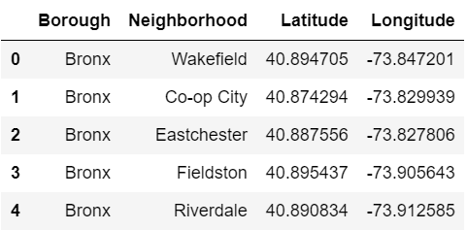

Data of Vietnamese restaurants in NYC is loaded from FourSquare API.

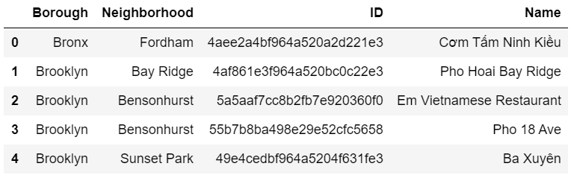

The number of Vietnamese restaurants in each borough of NYC

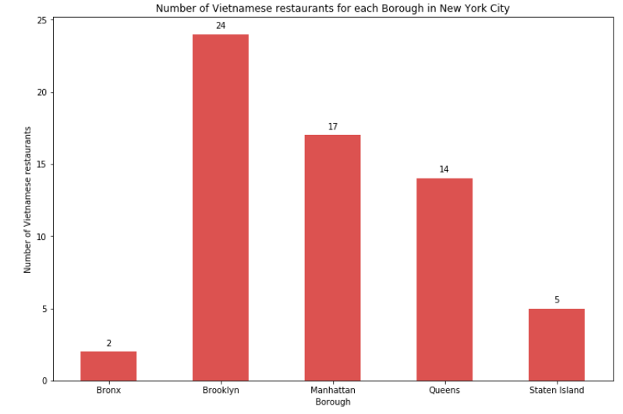

The number of Vietnamese restaurants in each neighborhood of Brooklyn, NYC.

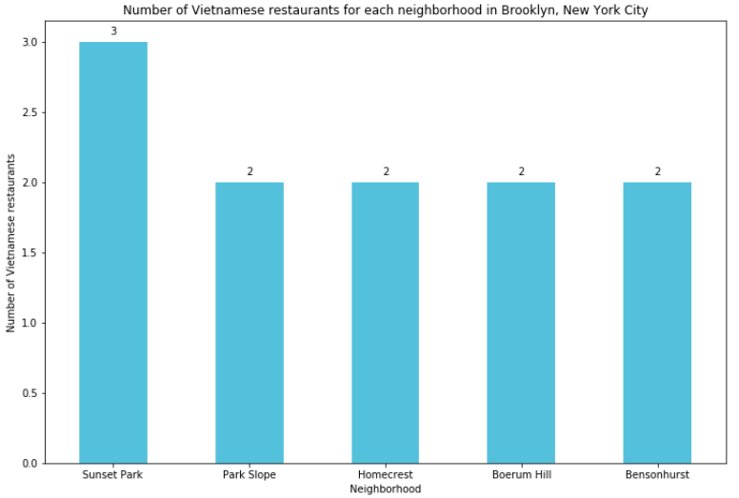

Next, the likes, rating and tip info of each Vietnamese restaurants in NY area is loaded from FourSquare API. The data is then preprocessed before analyzing.

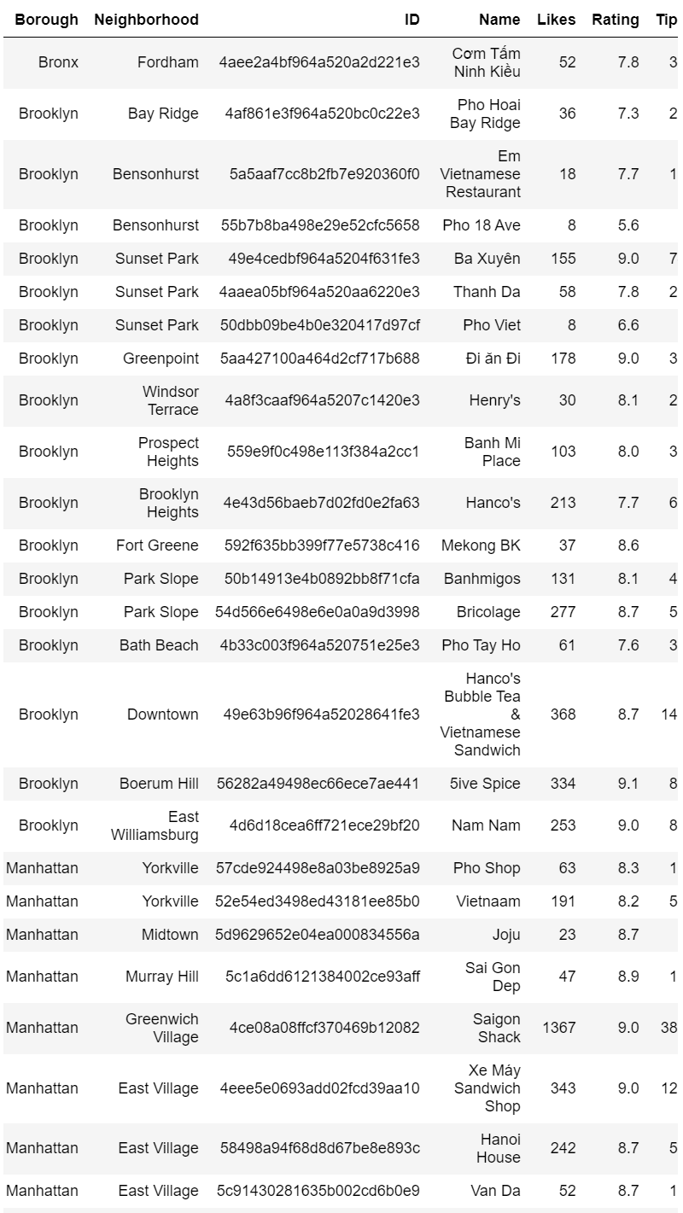

The graph shows the number of likes in each Vietnamese restaurants.

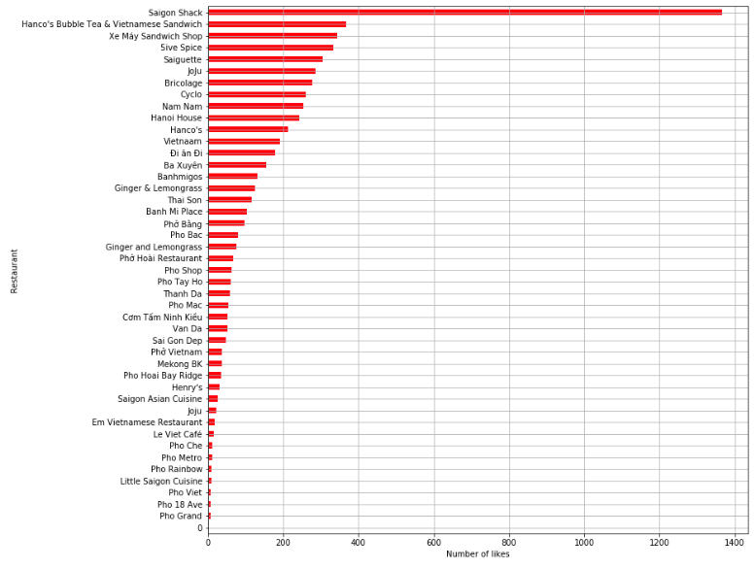

The graph below compares the rating of the restaurants.

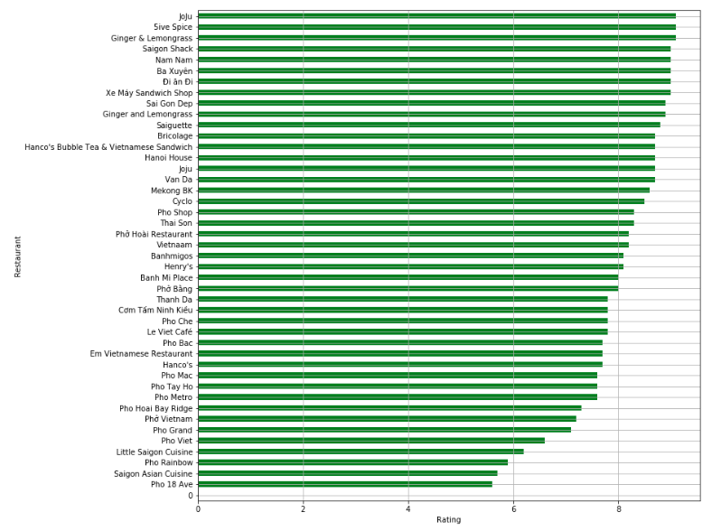

Tips in the restaurants are also compared in the figure below.

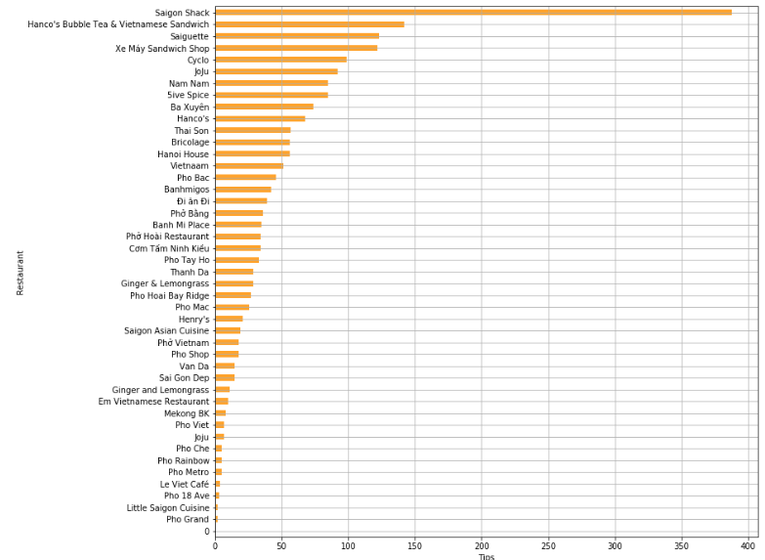

The list of neighborhoods which have average rating above 8.0

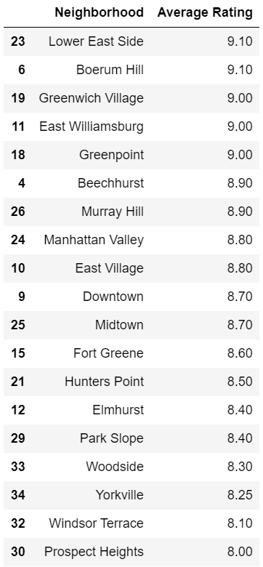

Folium library is used to visualize the list on a map of NYC

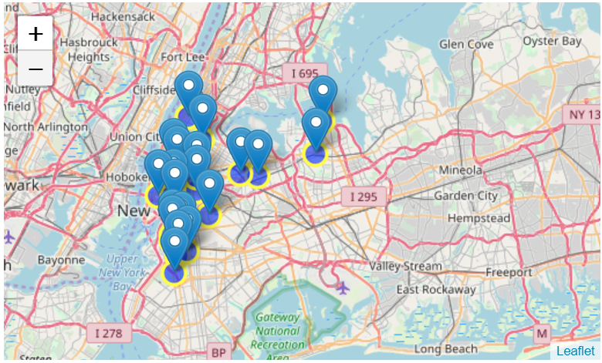

## **Conclusion**

* Noho (Manhattan), Greenpoint (Brooklyn), Greenwich Village (Manhattan) are some of the best neighborhoods for Vietnamese cuisine.
* Brooklyn have good potential Vietnamese restaurants.
* Manhattan is the best place to stay if you prefer Vietnamese Cuisine.
* 5iveSpice ranks first in rating of Vietnamese Restaurants in NYC.

## **Limitations**

* The ranking is purely on basis of rating of restaurants.
* The accuracy of data depends purely depends on the data provided by FourSquare.